Supplementary Material for HIV-1 matrix-31 membrane binding peptide interacts differently with membranes containing PS vs. PI(4,5)P₂

Lauren O’Neil¹, Kathryn Andenoro¹, Isabella Pagano¹, Laura Carroll¹, Leah Langer¹, Zachary Dell¹, Davina Perera², Bradley W. Treece¹, Frank Heinrich^{1,3}, Mathias Lösche^{1,3,4}, John F. Nagle¹ and Stephanie Tristram-Nagle^{1*}
¹Biological Physics Group, Physics Department, Carnegie Mellon University, Pittsburgh, PA 15213
² Biomedical Engineering, Douglass College, Rutgers University, New Brunswick, NJ 08901
³ National Institute of Standards and Technology Center for Neutron Research, Gaithersburg, MD 20899
⁴Biomedical Engineering, Carnegie Mellon University, Pittsburgh, PA 15213
*Corresponding author, 412-268-3174, FAX: 412-681-0648, stn@cmu.edu, http://www.cmu.edu/biolphys/jfstn
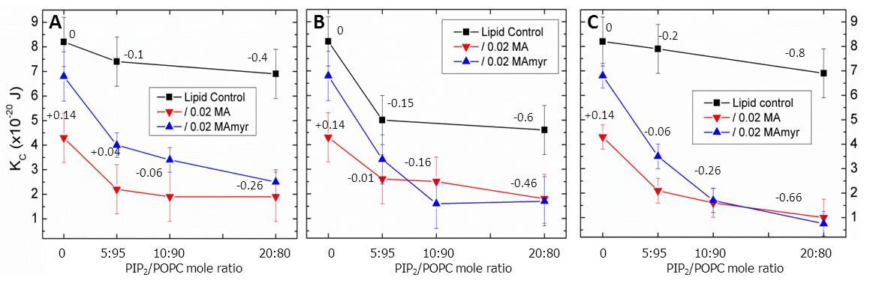
1. Additional Results for Bending Modulus. Panel C in Fig. S1 appears in Fig. 3C in the main text. Panels A and B show K_{C} when the number of phosphates in PIP₂ was systematically reduced. As the number of phosphate groups on the inositol headgroup increased, K_{C} decreased. Adding peptides further decreased K_{C} for any of the three lipid mixtures with different numbers of phosphates on the inositol headgroup. The lowest K_{C} values were seen for the highest negative net charge. Differences between MA₃₁ vs. MA₃₁myr occurred at lower concentrations of PI, PIP and PIP₂ as shown in Fig. S1A, B, C; the non-myristoylated form of MA₃₁ caused a greater decrease in K_{C} than did the myristoylated form, similar to their difference in mixtures with the neutral lipid, POPC (Fig. 3A). The difference in K_{C} between MA₃₁ vs. MA₃₁myr decreased as the net charge for the peptide-containing samples in Fig. S1A, B, C ranged from +0.14 to negative values.

Figure S1. Bending modulus, K_{C}, as a function of lipid and peptide concentration: (A) MA₃₁ and MA₃₁myr (0.02 mole fraction) in POPC with increasing PI, (B) MA₃₁ and MA₃₁myr (0.02) in POPC with increasing PIP, (C) MA₃₁ and MA₃₁myr (0.02) in POPC with increasing PIP₂. Numbers in Figs. S1A-C indicate the net membrane charge/lipid. Lipid control indicates samples with no peptides. Error bars represent standard deviations of the average K_{C} values from different samples.

2. Circular Dichroism (CD)
2.1 Samples for circular dichroism (CD) spectroscopy. Small unilamellar vesicles (SUVs) were prepared by sonicating MLV samples (0.2 mg/ml sample in water, with protein concentration 0.01 mg/ml) until a uniform translucency (~5-10 1 minute bursts on ice).
2.2. CD spectroscopy Methods. Ellipticity data were collected with a Jasco 715 at 37 ºC. For data analysis, a hyperplane routine supplied by OriginLab Corporation fitted the data over the wavelength range 200 to 240 nm. Hyperplane uses linear least squares to determine the coefficients for four structural motifs provided by the data set in [1] (see Fig. 9A) using the equation y=A0+(A1*x1)+(A2*x2)+(A3*x3)+(A4*x4). The four structural motifs are: 1, α-helix; 2, β-sheet; 3, β-turn; 4, random coil.
2.3. CD spectroscopy Results. Fig. S2A presents the ellipticity produced for pure motifs of α-helix, β-sheet, β-turn and random coil [1] which were used as described above to fit to the peptide ellipticity data. An example of the fit to a MA₃₁myr/POPC (1:50 mole ratio) SUV ellipticity data set is shown in Fig. S2B. The component motifs multiplied by their fitting coefficients are shown as grey lines. Importantly, there were no significant differences observed in secondary structure between MA₃₁ and MA₃₁myr. Surprisingly, the α-helix was higher and β-sheet content was lower in PC/PS lipids compared to in (i) water, (ii) neutral POPC lipids or (iii) charged POPC/PIP2 lipids.

Figure S2. Circular dichroism spectroscopy, (A) Brahms data set was used for fitting to the CD data. Dotted black vertical lines indicate the wavelength range used for the fit. (B) Representative fit (red solid line) for the ellipticity data from MA₃₁myr/POPC (1:50 mole ratio) SUVs (black solid line). The four components (grey lines) are the same as shown in Fig. S2A, multiplied by the coefficients determined in the data fitting. (C) Summary of CD results for samples as indicated. Shown errors are the standard deviation of duplicate samples.

3. Volumes
Molecular volume results were measured as described in Materials and Methods with results displayed in Table S1, where the masses of the counterions have been subtracted from the shown molecular weights of the peptides.
Table S1. Volume results at 37ºC

Peptide | MW | Volume (Å³)  In water | Density  (g/ml) | Volume (Å³)  In lipid | Density  (g/ml)
MA₃₁myr | 3708 | 5321±75 | 1.16 | 5090±91 | 1.21
MA₃₁ | 3498 | 4272±63 | 1.36 | 4223±5 | 1.38
Difference | 210 | 1049±138 | 0.20 | 869±96 | 0.17
The chemical difference between MA₃₁myr and MA₃₁ is a myristoyl whose volume in lipids we calculate to be 428 Å³, much smaller than the difference in volume between MA₃₁myr and MA₃₁ in Table S1. We repeated the volume measurements and we rechecked peptide purity because we found the measured large difference so surprising and difficult to explain. It would require that MA₃₁myr have an extra volume compared to MA₃₁ that cannot be filled by water, but with no discernable difference in secondary structure according to our CD results. We have tried to understand this in terms of the myristoyl switch, but have not succeeded, so this remains an unsolved puzzle. Fortunately, the results of the analysis of X-ray and neutron data in this paper are not so sensitive to 10% uncertainty in peptide volume to be of concern for the conclusions in this paper.

4. Neutron reflectivity (NR)
Fig. S3 shows the NR data obtained for POPC:POPS (60:40)/.01 MA as an example of the 68% confidence limits (pink lines) surrounding the peptide envelope (red line).

Figure S3. Neutron reflectivity profile showing peptide envelope (red) with 68% confidence limits (pink).

References for Supplementary Information

[1] S. Brahms, J. Brahms, Determination of protein secondary structure in solution by vacuum ultraviolet circular-dichroism, J Mol Biol, 138 (1980) 149-178.

