Supplemental Information: Enabling Marangoni flow at air-liquid interfaces through deposition of aerosolized lipid dispersions
Amy Z. Stettenª, Grace Moracaª, Timothy E. Corcoran^{b}, Stephanie Tristram-Nagleª, Stephen Garoff ^{a*}, Todd M. Przybycien^{c,d}, Robert D. Tilton^{c,d}

Center for Complex Fluids Engineering
ª Physics Department, Carnegie Mellon University, Pittsburgh, PA 15213, USA
^{b} Department of Medicine, University of Pittsburgh, Pittsburgh, PA 15260, USA
^{c} Department of Biomedical Engineering, Carnegie Mellon University, Pittsburgh, PA 15213, USA
^{d} Department of Chemical Engineering, Carnegie Mellon University, Pittsburgh, PA 15213, USA

Email Addresses:
astetten@andrew.cmu.edu (A. Stetten)
gmoraca1901@gmail.com (G. Moraca)
corcoranTE@upmc.edu (T. Corcoran)
stn@cmu.edu (S. Tristram-Nagle)
sg2e@andrew.cmu.edu (S. Garoff)
todd@andrew.cmu.edu (T. Przybycien)
tilton@andrew.cmu.edu (R. Tilton)
*Corresponding Author. Email sg2e@andrew.cmu.edu

In Figure S1, we show a select set of experiments performed with two different nebulizers (vibrating mesh and jet) on three different subphases defined in the main manuscript (water, PA, and PGM). All experiments shown here were performed with 10 mg/mL DMPC MLV dispersions. Although the experiments performed with the vibrating mesh nebulizer ran out of material before reaching very low (< 10 mN/m) surface tensions, these low surface tensions were achievable through loading the mesh nebulizer multiple times (see Figure 8). All of these experiments showed consistent results: the surface tension of the subphase was lowered significantly and the indicator particle fully traversed the experimental trough.

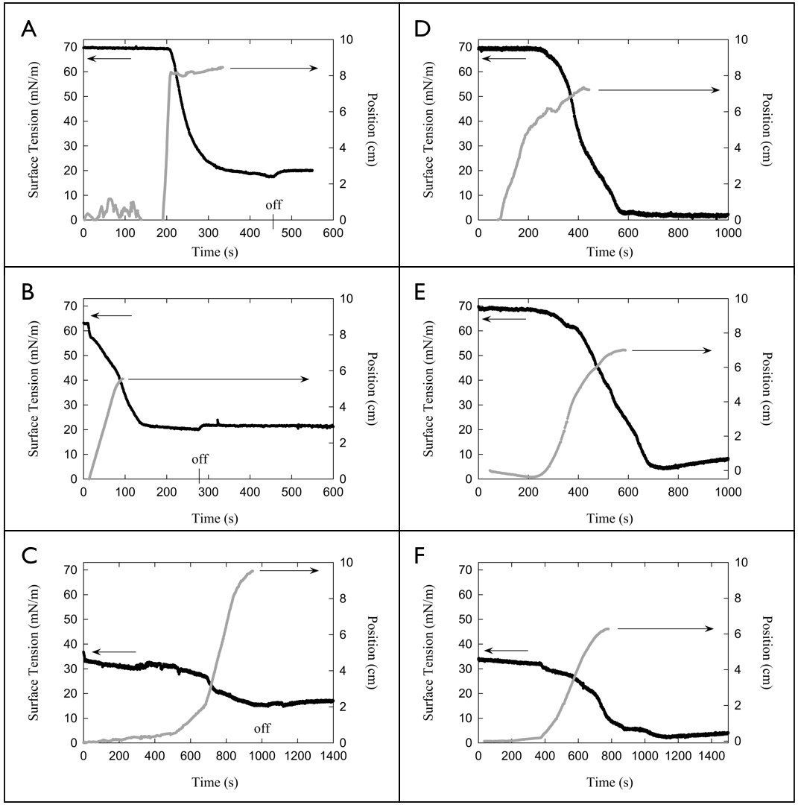
Figure S1: Six examples of surface tension reduction and Marangoni transport. Columns show results from different nebulizers and rows show results on different subphases. A, B, and C were performed using the vibrating mesh nebulizer. D, E, and F were performed using the jet nebulizer. A and D were performed on a water subphase, B and E were performed on a PA subphase, and C and F were performed on a PGM subphase. For vibrating mesh nebulizer trials that ran out of material, the point at which the nebulizer turned off is marked “off”.

Figure S2 shows the surface pressure/area isotherm created by depositing DMPC dissolved in chloroform drop-wise onto a DI water subphase. This isotherm, though not performed in the traditional Langmuir trough method, is in good agreement with the literature.
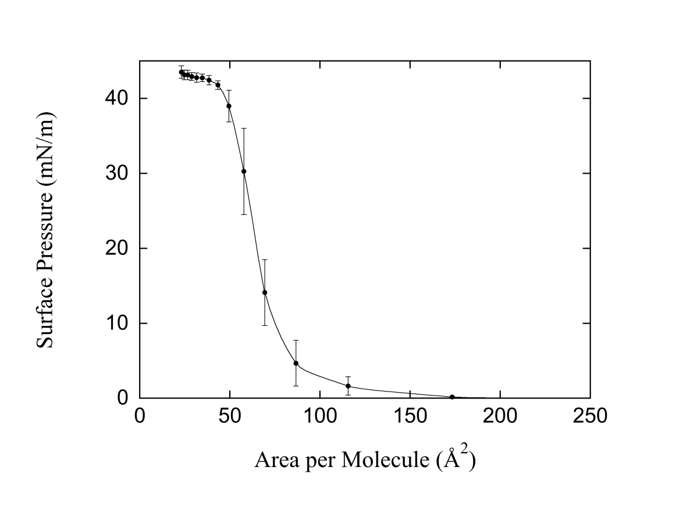
Figure S2: Surface pressure isotherm for DMPC on de-ionized water at 25°C

In Figure S3, we show a video clip of subsurface flow on water taken via the microscopy technique described within the methods section of the main text. In the images in Figures 5 and 6, the lipid clusters appear white; here they appear black due to lighting differences. In this clip, the dark lipid clusters moving beneath the surface are at a depth of approximately 200 μm. The clip begins approximately 5 minutes and 50 seconds after the nebulizer has been turned on. The clusters can be seen to move across the field of view from left to right (outward from the region of deposition to the left). The cluster field moves together and speeds up as the movie progresses.

Figure S3: Video of subsurface flow on water. The field of view is 3440 μm by 2752 μm focused at a depth of approximately 200 μm. The region of aerosol deposition is to the viewer’s left. Lipid clusters can be seen as dark spots moving across the field of view from left to right.

